alpha =2

1 run......

Downloading: 100%

411/411 [00:00<00:00, 11.4kB/s]

Downloading: 100%

263M/263M [00:10<00:00, 29.3MB/s]

training 1 epoch...

117.72466921806335 seconds used......

1 training finished! average train loss: 2.045330740866207

total clf loss: 166.8595415353775 total adv loss: 88.37801134586334

evaluating...

Confusion matrix, without normalization

[[ 93 22 9]

[ 45 115 4]

[573 82 210]]

Normalized confusion matrix

[[0.75 0.17741935 0.07258065]

[0.27439024 0.70121951 0.02439024]

[0.66242775 0.09479769 0.24277457]]

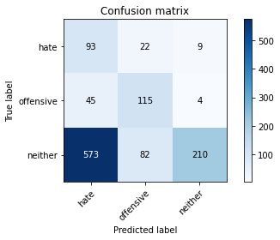

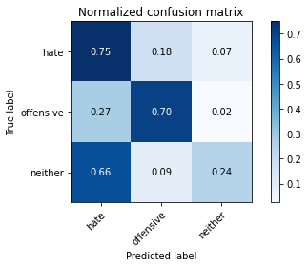

precision recall f1-score support

hate 0.13 0.75 0.22 124

offensive 0.53 0.70 0.60 164

neither 0.94 0.24 0.39 865

accuracy 0.36 1153

macro avg 0.53 0.56 0.40 1153

weighted avg 0.80 0.36 0.40 1153

average eval_loss: 0.9667034663003067, accuracy: 0.36253252385082396

training 2 epoch...

116.55714678764343 seconds used......

2 training finished! average train loss: 1.6917496497432392

total clf loss: 142.24134397506714 total adv loss: 70.98629872500896

evaluating...

Confusion matrix, without normalization

[[ 77 38 9]

[ 31 125 8]

[424 110 331]]

Normalized confusion matrix

[[0.62096774 0.30645161 0.07258065]

[0.18902439 0.76219512 0.04878049]

[0.49017341 0.12716763 0.38265896]]

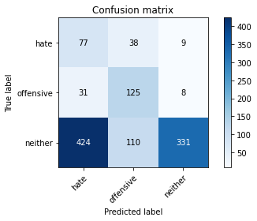

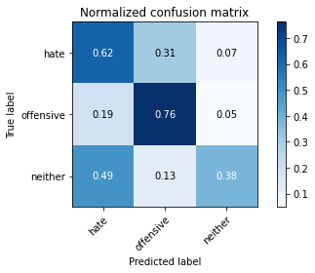

precision recall f1-score support

hate 0.14 0.62 0.23 124

offensive 0.46 0.76 0.57 164

neither 0.95 0.38 0.55 865

accuracy 0.46 1153

macro avg 0.52 0.59 0.45 1153

weighted avg 0.79 0.46 0.52 1153

average eval_loss: 0.9311523355286697, accuracy: 0.46227233304423243

training 3 epoch...

116.50543475151062 seconds used......

3 training finished! average train loss: 1.372547050671918

total clf loss: 122.64872518181801 total adv loss: 53.96958977729082

evaluating...

Confusion matrix, without normalization

[[ 69 42 13]

[ 26 123 15]

[400 97 368]]

Normalized confusion matrix

[[0.55645161 0.33870968 0.10483871]

[0.15853659 0.75 0.09146341]

[0.46242775 0.11213873 0.42543353]]

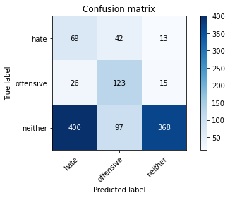

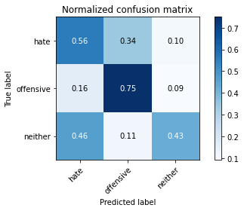

precision recall f1-score support

hate 0.14 0.56 0.22 124

offensive 0.47 0.75 0.58 164

neither 0.93 0.43 0.58 865

accuracy 0.49 1153

macro avg 0.51 0.58 0.46 1153

weighted avg 0.78 0.49 0.54 1153

average eval_loss: 0.9271299551273214, accuracy: 0.4856895056374675

training 4 epoch...

116.7252938747406 seconds used......

4 training finished! average train loss: 0.9217435873690105

total clf loss: 93.15225307643414 total adv loss: 30.85033466666937

evaluating...

Confusion matrix, without normalization

[[ 67 29 28]

[ 20 121 23]

[310 83 472]]

Normalized confusion matrix

[[0.54032258 0.23387097 0.22580645]

[0.12195122 0.73780488 0.1402439 ]

[0.3583815 0.09595376 0.54566474]]

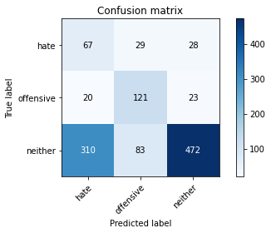

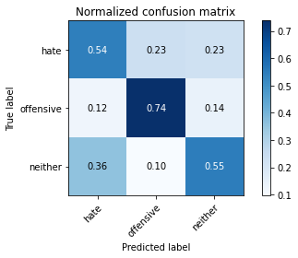

precision recall f1-score support

hate 0.17 0.54 0.26 124

offensive 0.52 0.74 0.61 164

neither 0.90 0.55 0.68 865

accuracy 0.57 1153

macro avg 0.53 0.61 0.52 1153

weighted avg 0.77 0.57 0.62 1153

average eval_loss: 0.9499192628367193, accuracy: 0.572419774501301

training 5 epoch...

116.73481941223145 seconds used......

5 training finished! average train loss: 0.6059280855669862

total clf loss: 70.00384619832039 total adv loss: 15.896036279911641

evaluating...

Confusion matrix, without normalization

[[ 78 25 21]

[ 37 105 22]

[309 70 486]]

Normalized confusion matrix

[[0.62903226 0.2016129 0.16935484]

[0.22560976 0.6402439 0.13414634]

[0.35722543 0.08092486 0.56184971]]

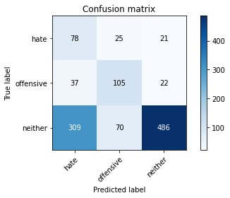

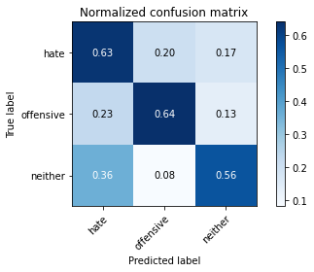

precision recall f1-score support

hate 0.18 0.63 0.28 124

offensive 0.53 0.64 0.58 164

neither 0.92 0.56 0.70 865

accuracy 0.58 1153

macro avg 0.54 0.61 0.52 1153

weighted avg 0.78 0.58 0.64 1153

average eval_loss: 1.0197866199345424, accuracy: 0.5802254986990459

training 6 epoch...

116.7108325958252 seconds used......

6 training finished! average train loss: 0.43677727235037656

total clf loss: 53.40205802768469 total adv loss: 9.988261822116328

evaluating...

Confusion matrix, without normalization

[[ 77 19 28]

[ 37 97 30]

[340 60 465]]

Normalized confusion matrix

[[0.62096774 0.15322581 0.22580645]

[0.22560976 0.59146341 0.18292683]

[0.39306358 0.06936416 0.53757225]]

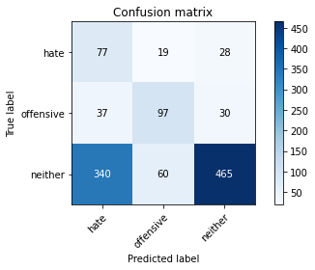

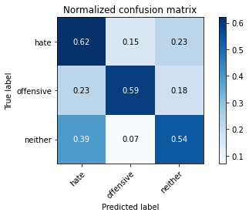

precision recall f1-score support

hate 0.17 0.62 0.27 124

offensive 0.55 0.59 0.57 164

neither 0.89 0.54 0.67 865

accuracy 0.55 1153

macro avg 0.54 0.58 0.50 1153

weighted avg 0.76 0.55 0.61 1153

average eval_loss: 1.138783840269878, accuracy: 0.5542064180398959

training 7 epoch...

116.66608595848083 seconds used......

7 training finished! average train loss: 0.29294383202102925

total clf loss: 35.35767175257206 total adv loss: 6.928446008285391

evaluating...

Confusion matrix, without normalization

[[ 79 36 9]

[ 37 121 6]

[466 90 309]]

Normalized confusion matrix

[[0.63709677 0.29032258 0.07258065]

[0.22560976 0.73780488 0.03658537]

[0.53872832 0.10404624 0.35722543]]

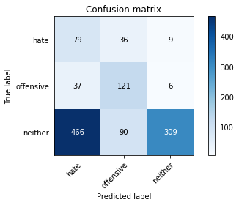

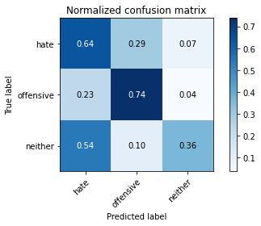

precision recall f1-score support

hate 0.14 0.64 0.22 124

offensive 0.49 0.74 0.59 164

neither 0.95 0.36 0.52 865

accuracy 0.44 1153

macro avg 0.53 0.58 0.44 1153

weighted avg 0.80 0.44 0.50 1153

average eval_loss: 1.9295724856442418, accuracy: 0.4414570685169124

training 8 epoch...

116.78544020652771 seconds used......

8 training finished! average train loss: 0.17365612599643923

total clf loss: 20.87768699042499 total adv loss: 4.14827096693989

evaluating...

Confusion matrix, without normalization

[[ 66 36 22]

[ 20 119 25]

[316 90 459]]

Normalized confusion matrix

[[0.53225806 0.29032258 0.17741935]

[0.12195122 0.72560976 0.15243902]

[0.36531792 0.10404624 0.53063584]]

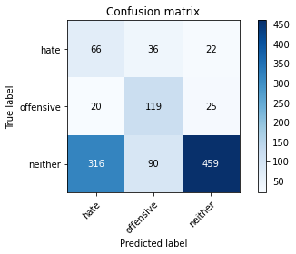

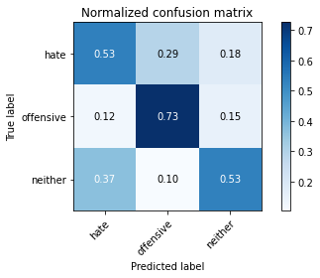

precision recall f1-score support

hate 0.16 0.53 0.25 124

offensive 0.49 0.73 0.58 164

neither 0.91 0.53 0.67 865

accuracy 0.56 1153

macro avg 0.52 0.60 0.50 1153

weighted avg 0.77 0.56 0.61 1153

average eval_loss: 1.6240051172930619, accuracy: 0.5585429314830876

training 9 epoch...

116.70117092132568 seconds used......

9 training finished! average train loss: 0.16058870103941963

total clf loss: 17.41922860685736 total adv loss: 4.7798366055722

evaluating...

Confusion matrix, without normalization

[[ 63 38 23]

[ 24 122 18]

[339 84 442]]

Normalized confusion matrix

[[0.50806452 0.30645161 0.18548387]

[0.14634146 0.74390244 0.1097561 ]

[0.39190751 0.09710983 0.51098266]]

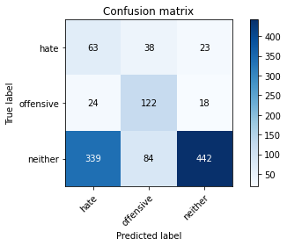

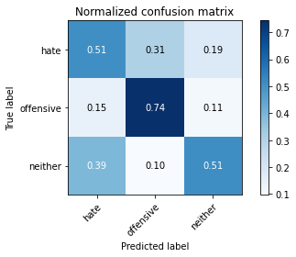

precision recall f1-score support

hate 0.15 0.51 0.23 124

offensive 0.50 0.74 0.60 164

neither 0.92 0.51 0.66 865

accuracy 0.54 1153

macro avg 0.52 0.59 0.49 1153

weighted avg 0.77 0.54 0.60 1153

average eval_loss: 1.8414660579171673, accuracy: 0.5437987857762359

training 10 epoch...

116.6551411151886 seconds used......

10 training finished! average train loss: 0.13683612635802656

total clf loss: 12.390533375553787 total adv loss: 5.298967934104439

evaluating...

Confusion matrix, without normalization

[[106 10 8]

[ 55 92 17]

[491 33 341]]

Normalized confusion matrix

[[0.85483871 0.08064516 0.06451613]

[0.33536585 0.56097561 0.10365854]

[0.56763006 0.03815029 0.39421965]]

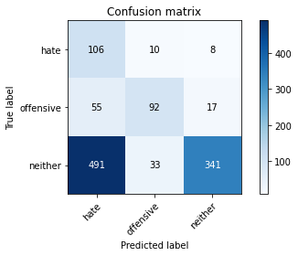

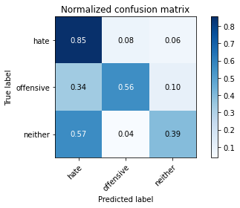

precision recall f1-score support

hate 0.16 0.85 0.27 124

offensive 0.68 0.56 0.62 164

neither 0.93 0.39 0.55 865

accuracy 0.47 1153

macro avg 0.59 0.60 0.48 1153

weighted avg 0.81 0.47 0.53 1153

average eval_loss: 2.389793691963985, accuracy: 0.46747614917606245

2 run......

training 1 epoch...

116.73562288284302 seconds used......

1 training finished! average train loss: 2.0740043095179965

total clf loss: 167.86878460645676 total adv loss: 90.28196875751019

evaluating...

Confusion matrix, without normalization

[[ 93 15 16]

[ 51 98 15]

[489 51 325]]

Normalized confusion matrix

[[0.75 0.12096774 0.12903226]

[0.31097561 0.59756098 0.09146341]

[0.56531792 0.05895954 0.37572254]]

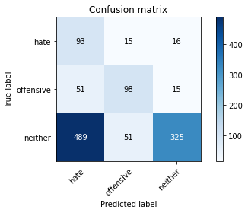

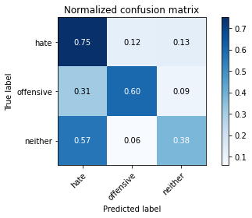

precision recall f1-score support

hate 0.15 0.75 0.25 124

offensive 0.60 0.60 0.60 164

neither 0.91 0.38 0.53 865

accuracy 0.45 1153

macro avg 0.55 0.57 0.46 1153

weighted avg 0.79 0.45 0.51 1153

average eval_loss: 0.9054599979828144, accuracy: 0.44752818733738076

training 2 epoch...

116.67211294174194 seconds used......

2 training finished! average train loss: 1.742113369561377

total clf loss: 145.3395945429802 total adv loss: 73.66772569715977

evaluating...

Confusion matrix, without normalization

[[ 85 23 16]

[ 33 120 11]

[310 77 478]]

Normalized confusion matrix

[[0.68548387 0.18548387 0.12903226]

[0.20121951 0.73170732 0.06707317]

[0.3583815 0.08901734 0.55260116]]

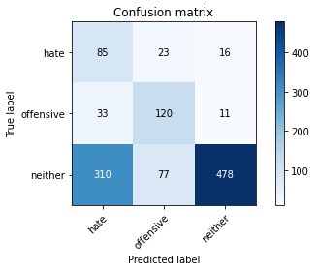

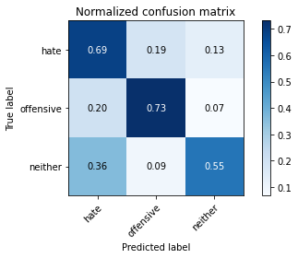

precision recall f1-score support

hate 0.20 0.69 0.31 124

offensive 0.55 0.73 0.62 164

neither 0.95 0.55 0.70 865

accuracy 0.59 1153

macro avg 0.56 0.66 0.54 1153

weighted avg 0.81 0.59 0.65 1153

average eval_loss: 0.8337641173395617, accuracy: 0.5923677363399826

training 3 epoch...

116.89646482467651 seconds used......

3 training finished! average train loss: 1.4261064458461035

total clf loss: 124.9586076438427 total adv loss: 57.31363772600889

evaluating...

Confusion matrix, without normalization

[[ 97 21 6]

[ 47 113 4]

[566 65 234]]

Normalized confusion matrix

[[0.78225806 0.16935484 0.0483871 ]

[0.28658537 0.68902439 0.02439024]

[0.65433526 0.07514451 0.27052023]]

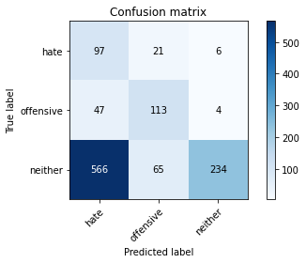

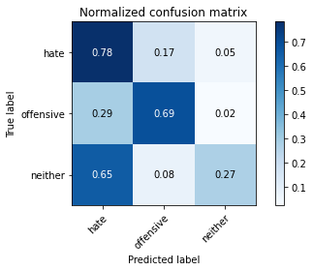

precision recall f1-score support

hate 0.14 0.78 0.23 124

offensive 0.57 0.69 0.62 164

neither 0.96 0.27 0.42 865

accuracy 0.39 1153

macro avg 0.55 0.58 0.43 1153

weighted avg 0.81 0.39 0.43 1153

average eval_loss: 0.9807268730525313, accuracy: 0.38508239375542064

training 4 epoch...

116.8149802684784 seconds used......

4 training finished! average train loss: 0.9473805097596986

total clf loss: 94.57723742723465 total adv loss: 32.291343968361616

evaluating...

Confusion matrix, without normalization

[[ 85 30 9]

[ 38 117 9]

[390 94 381]]

Normalized confusion matrix

[[0.68548387 0.24193548 0.07258065]

[0.23170732 0.71341463 0.05487805]

[0.45086705 0.10867052 0.44046243]]

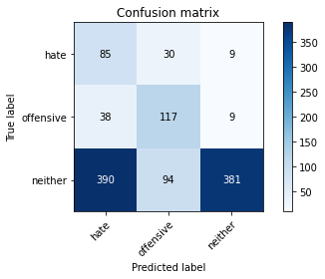

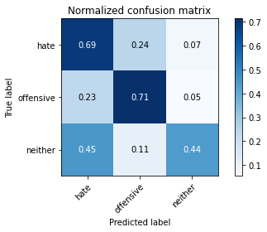

precision recall f1-score support

hate 0.17 0.69 0.27 124

offensive 0.49 0.71 0.58 164

neither 0.95 0.44 0.60 865

accuracy 0.51 1153

macro avg 0.54 0.61 0.48 1153

weighted avg 0.80 0.51 0.56 1153

average eval_loss: 1.0002583686647744, accuracy: 0.5056374674761491

training 5 epoch...

116.77600646018982 seconds used......

5 training finished! average train loss: 0.5959838544506402

total clf loss: 69.63872355222702 total adv loss: 15.243282029114198

evaluating...

Confusion matrix, without normalization

[[ 92 23 9]

[ 40 113 11]

[425 78 362]]

Normalized confusion matrix

[[0.74193548 0.18548387 0.07258065]

[0.24390244 0.68902439 0.06707317]

[0.49132948 0.09017341 0.41849711]]

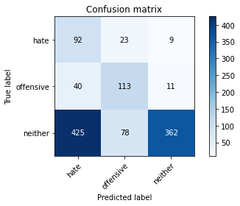

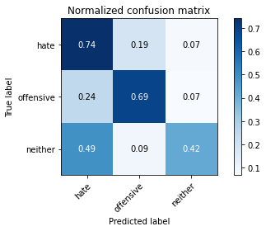

precision recall f1-score support

hate 0.17 0.74 0.27 124

offensive 0.53 0.69 0.60 164

neither 0.95 0.42 0.58 865

accuracy 0.49 1153

macro avg 0.55 0.62 0.48 1153

weighted avg 0.80 0.49 0.55 1153

average eval_loss: 1.1190592173872322, accuracy: 0.49176062445793584

training 6 epoch...

116.7277159690857 seconds used......

6 training finished! average train loss: 0.43682828660876977

total clf loss: 51.72099007666111 total adv loss: 10.83308097475674

evaluating...

Confusion matrix, without normalization

[[ 91 21 12]

[ 40 106 18]

[354 58 453]]

Normalized confusion matrix

[[0.73387097 0.16935484 0.09677419]

[0.24390244 0.64634146 0.1097561 ]

[0.40924855 0.06705202 0.52369942]]

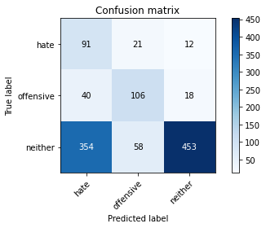

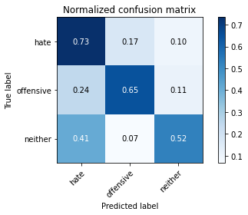

precision recall f1-score support

hate 0.19 0.73 0.30 124

offensive 0.57 0.65 0.61 164

neither 0.94 0.52 0.67 865

accuracy 0.56 1153

macro avg 0.57 0.63 0.53 1153

weighted avg 0.81 0.56 0.62 1153

average eval_loss: 1.22449477376609, accuracy: 0.5637467476149176

training 7 epoch...

116.59623575210571 seconds used......

7 training finished! average train loss: 0.294061831154284

total clf loss: 36.141088239848614 total adv loss: 6.63064967696846

evaluating...

Confusion matrix, without normalization

[[ 93 18 13]

[ 50 102 12]

[394 50 421]]

Normalized confusion matrix

[[0.75 0.14516129 0.10483871]

[0.30487805 0.62195122 0.07317073]

[0.45549133 0.05780347 0.4867052 ]]

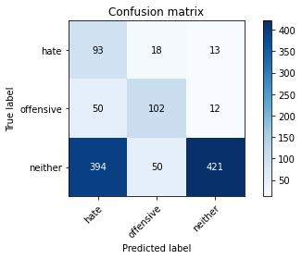

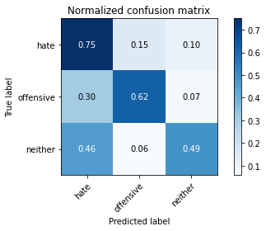

precision recall f1-score support

hate 0.17 0.75 0.28 124

offensive 0.60 0.62 0.61 164

neither 0.94 0.49 0.64 865

accuracy 0.53 1153

macro avg 0.57 0.62 0.51 1153

weighted avg 0.81 0.53 0.60 1153

average eval_loss: 1.5692104183394333, accuracy: 0.5342584562012143

training 8 epoch...

116.87071442604065 seconds used......

8 training finished! average train loss: 0.20203996945305594

total clf loss: 24.09193411655724 total adv loss: 4.925390466007229

evaluating...

Confusion matrix, without normalization

[[ 93 22 9]

[ 39 112 13]

[453 74 338]]

Normalized confusion matrix

[[0.75 0.17741935 0.07258065]

[0.23780488 0.68292683 0.07926829]

[0.52369942 0.08554913 0.39075145]]

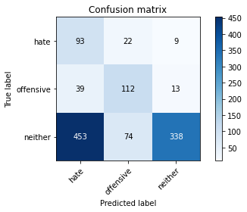

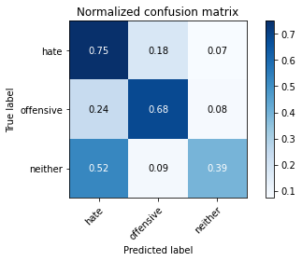

precision recall f1-score support

hate 0.16 0.75 0.26 124

offensive 0.54 0.68 0.60 164

neither 0.94 0.39 0.55 865

accuracy 0.47 1153

macro avg 0.55 0.61 0.47 1153

weighted avg 0.80 0.47 0.53 1153

average eval_loss: 1.8939373688451175, accuracy: 0.47094535993061576

training 9 epoch...

116.85460662841797 seconds used......

9 training finished! average train loss: 0.1537530440338222

total clf loss: 16.90862503927201 total adv loss: 4.460943251780918

evaluating...

Confusion matrix, without normalization

[[100 18 6]

[ 50 106 8]

[554 70 241]]

Normalized confusion matrix

[[0.80645161 0.14516129 0.0483871 ]

[0.30487805 0.64634146 0.04878049]

[0.64046243 0.08092486 0.27861272]]

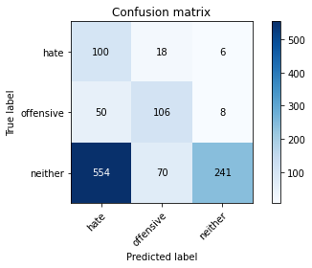

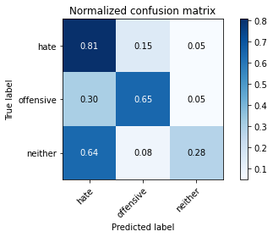

precision recall f1-score support

hate 0.14 0.81 0.24 124

offensive 0.55 0.65 0.59 164

neither 0.95 0.28 0.43 865

accuracy 0.39 1153

macro avg 0.54 0.58 0.42 1153

weighted avg 0.80 0.39 0.43 1153

average eval_loss: 2.7533680632196624, accuracy: 0.3876843018213356

training 10 epoch...

116.65132355690002 seconds used......

10 training finished! average train loss: 0.1226374699617736

total clf loss: 12.859499169979244 total adv loss: 3.8717978933564154

evaluating...

Confusion matrix, without normalization

[[ 89 22 13]

[ 44 103 17]

[396 58 411]]

Normalized confusion matrix

[[0.71774194 0.17741935 0.10483871]

[0.26829268 0.62804878 0.10365854]

[0.45780347 0.06705202 0.47514451]]

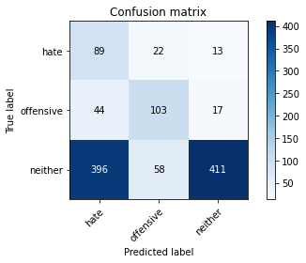

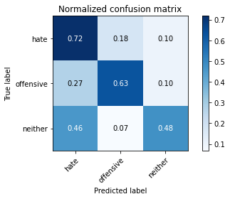

precision recall f1-score support

hate 0.17 0.72 0.27 124

offensive 0.56 0.63 0.59 164

neither 0.93 0.48 0.63 865

accuracy 0.52 1153

macro avg 0.55 0.61 0.50 1153

weighted avg 0.80 0.52 0.59 1153

average eval_loss: 1.9919815885609593, accuracy: 0.5229835212489159

3 run......

training 1 epoch...

116.68182253837585 seconds used......

1 training finished! average train loss: 2.0889399626425336

total clf loss: 168.35618388652802 total adv loss: 91.29286447167397

evaluating...

Confusion matrix, without normalization

[[ 85 31 8]

[ 42 120 2]

[522 141 202]]

Normalized confusion matrix

[[0.68548387 0.25 0.06451613]

[0.25609756 0.73170732 0.01219512]

[0.60346821 0.16300578 0.23352601]]

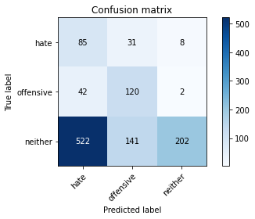

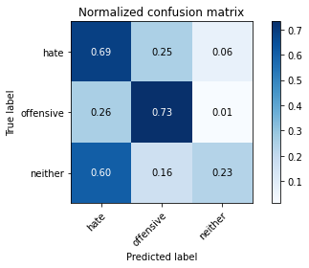

precision recall f1-score support

hate 0.13 0.69 0.22 124

offensive 0.41 0.73 0.53 164

neither 0.95 0.23 0.38 865

accuracy 0.35 1153

macro avg 0.50 0.55 0.37 1153

weighted avg 0.79 0.35 0.38 1153

average eval_loss: 0.9949770497864691, accuracy: 0.35299219427580225

training 2 epoch...

116.61755752563477 seconds used......

2 training finished! average train loss: 1.7142069680350167

total clf loss: 144.14270132780075 total adv loss: 71.92203469574451

evaluating...

Confusion matrix, without normalization

[[ 91 22 11]

[ 45 108 11]

[439 76 350]]

Normalized confusion matrix

[[0.73387097 0.17741935 0.08870968]

[0.27439024 0.65853659 0.06707317]

[0.50751445 0.08786127 0.40462428]]

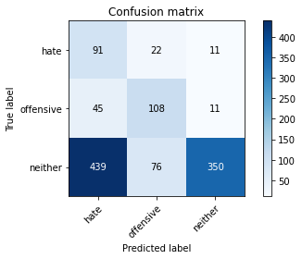

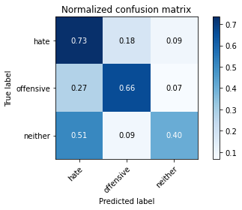

precision recall f1-score support

hate 0.16 0.73 0.26 124

offensive 0.52 0.66 0.58 164

neither 0.94 0.40 0.57 865

accuracy 0.48 1153

macro avg 0.54 0.60 0.47 1153

weighted avg 0.80 0.48 0.54 1153

average eval_loss: 0.9054617563198353, accuracy: 0.4761491760624458

training 3 epoch...

116.67203712463379 seconds used......

3 training finished! average train loss: 1.3621947619886625

total clf loss: 121.910788834095 total adv loss: 53.46896585077047

evaluating...

Confusion matrix, without normalization

[[ 83 21 20]

[ 38 111 15]

[279 66 520]]

Normalized confusion matrix

[[0.66935484 0.16935484 0.16129032]

[0.23170732 0.67682927 0.09146341]

[0.32254335 0.07630058 0.60115607]]

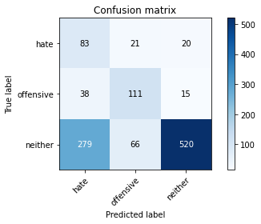

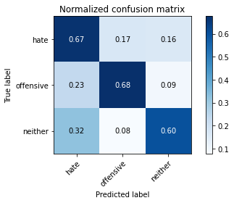

precision recall f1-score support

hate 0.21 0.67 0.32 124

offensive 0.56 0.68 0.61 164

neither 0.94 0.60 0.73 865

accuracy 0.62 1153

macro avg 0.57 0.65 0.55 1153

weighted avg 0.80 0.62 0.67 1153

average eval_loss: 0.8197343657756674, accuracy: 0.619254119687771

training 4 epoch...

116.71838331222534 seconds used......

4 training finished! average train loss: 0.9100249922346502

total clf loss: 93.31524106860161 total adv loss: 29.78447883017361

evaluating...

Confusion matrix, without normalization

[[ 94 19 11]

[ 46 101 17]

[478 65 322]]

Normalized confusion matrix

[[0.75806452 0.15322581 0.08870968]

[0.2804878 0.61585366 0.10365854]

[0.55260116 0.07514451 0.37225434]]

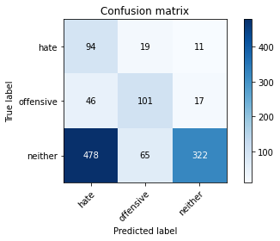

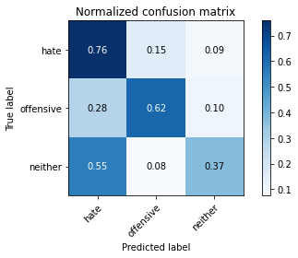

precision recall f1-score support

hate 0.15 0.76 0.25 124

offensive 0.55 0.62 0.58 164

neither 0.92 0.37 0.53 865

accuracy 0.45 1153

macro avg 0.54 0.58 0.45 1153

weighted avg 0.78 0.45 0.51 1153

average eval_loss: 1.1122602933439716, accuracy: 0.4483954900260191

training 5 epoch...

116.75116515159607 seconds used......

5 training finished! average train loss: 0.5947240410106522

total clf loss: 71.00570033490658 total adv loss: 14.45396927127149

evaluating...

Confusion matrix, without normalization

[[ 94 22 8]

[ 46 108 10]

[514 81 270]]

Normalized confusion matrix

[[0.75806452 0.17741935 0.06451613]

[0.2804878 0.65853659 0.06097561]

[0.59421965 0.09364162 0.31213873]]

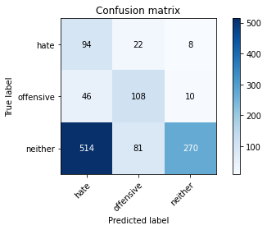

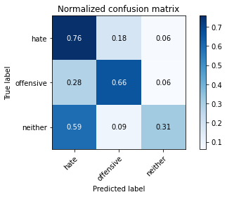

precision recall f1-score support

hate 0.14 0.76 0.24 124

offensive 0.51 0.66 0.58 164

neither 0.94 0.31 0.47 865

accuracy 0.41 1153

macro avg 0.53 0.58 0.43 1153

weighted avg 0.79 0.41 0.46 1153

average eval_loss: 1.4057766229941928, accuracy: 0.409366869037294

training 6 epoch...

116.64962720870972 seconds used......

6 training finished! average train loss: 0.42150980340582983

total clf loss: 51.827586464583874 total adv loss: 9.493030330791953

evaluating...

Confusion matrix, without normalization

[[ 98 19 7]

[ 42 113 9]

[499 89 277]]

Normalized confusion matrix

[[0.79032258 0.15322581 0.05645161]

[0.25609756 0.68902439 0.05487805]

[0.57687861 0.10289017 0.32023121]]

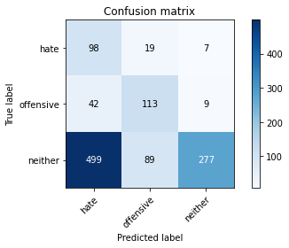

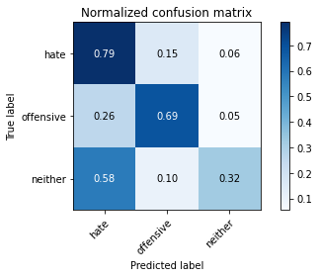

precision recall f1-score support

hate 0.15 0.79 0.26 124

offensive 0.51 0.69 0.59 164

neither 0.95 0.32 0.48 865

accuracy 0.42 1153

macro avg 0.54 0.60 0.44 1153

weighted avg 0.80 0.42 0.47 1153

average eval_loss: 1.7245522254499897, accuracy: 0.42324371205550737

training 7 epoch...

116.61771178245544 seconds used......

7 training finished! average train loss: 0.28213231979558867

total clf loss: 35.30702297016978 total adv loss: 6.045603329825099

evaluating...

Confusion matrix, without normalization

[[ 94 19 11]

[ 38 110 16]

[461 75 329]]

Normalized confusion matrix

[[0.75806452 0.15322581 0.08870968]

[0.23170732 0.67073171 0.09756098]

[0.53294798 0.0867052 0.38034682]]

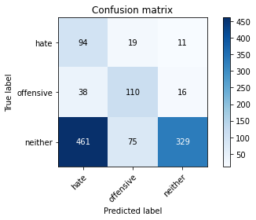

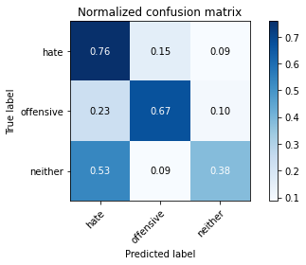

precision recall f1-score support

hate 0.16 0.76 0.26 124

offensive 0.54 0.67 0.60 164

neither 0.92 0.38 0.54 865

accuracy 0.46 1153

macro avg 0.54 0.60 0.47 1153

weighted avg 0.79 0.46 0.52 1153

average eval_loss: 1.845236304505118, accuracy: 0.46227233304423243

training 8 epoch...

116.80557417869568 seconds used......

8 training finished! average train loss: 0.24266856953146912

total clf loss: 26.75060878507793 total adv loss: 7.00885548453698

evaluating...

Confusion matrix, without normalization

[[ 91 24 9]

[ 38 116 10]

[455 111 299]]

Normalized confusion matrix

[[0.73387097 0.19354839 0.07258065]

[0.23170732 0.70731707 0.06097561]

[0.52601156 0.1283237 0.34566474]]

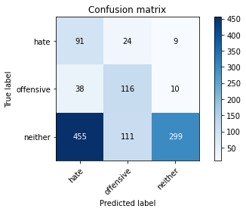

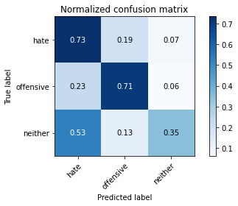

precision recall f1-score support

hate 0.16 0.73 0.26 124

offensive 0.46 0.71 0.56 164

neither 0.94 0.35 0.51 865

accuracy 0.44 1153

macro avg 0.52 0.60 0.44 1153

weighted avg 0.79 0.44 0.49 1153

average eval_loss: 1.9390856633926261, accuracy: 0.4388551604509974

training 9 epoch...

116.63934063911438 seconds used......

9 training finished! average train loss: 0.178078139034499

total clf loss: 19.87714291550219 total adv loss: 5.019992231512788

evaluating...

Confusion matrix, without normalization

[[ 84 23 17]

[ 37 110 17]

[411 76 378]]

Normalized confusion matrix

[[0.67741935 0.18548387 0.13709677]

[0.22560976 0.67073171 0.10365854]

[0.47514451 0.08786127 0.43699422]]

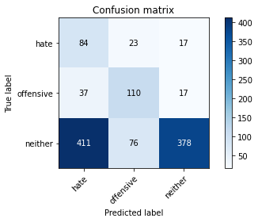

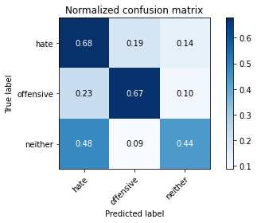

precision recall f1-score support

hate 0.16 0.68 0.26 124

offensive 0.53 0.67 0.59 164

neither 0.92 0.44 0.59 865

accuracy 0.50 1153

macro avg 0.53 0.60 0.48 1153

weighted avg 0.78 0.50 0.56 1153

average eval_loss: 1.9890916830506817, accuracy: 0.49609713790112747

training 10 epoch...

116.6016149520874 seconds used......

10 training finished! average train loss: 0.11422747254116639

total clf loss: 12.2578658265993 total adv loss: 3.466174752356892

evaluating...

Confusion matrix, without normalization

[[ 99 16 9]

[ 46 103 15]

[497 62 306]]

Normalized confusion matrix

[[0.7983871 0.12903226 0.07258065]

[0.2804878 0.62804878 0.09146341]

[0.57456647 0.0716763 0.35375723]]

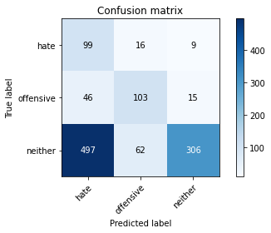

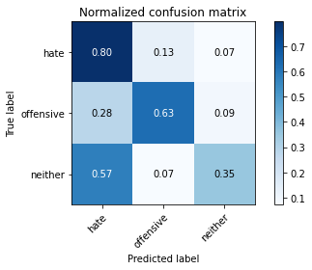

precision recall f1-score support

hate 0.15 0.80 0.26 124

offensive 0.57 0.63 0.60 164

neither 0.93 0.35 0.51 865

accuracy 0.44 1153

macro avg 0.55 0.59 0.46 1153

weighted avg 0.79 0.44 0.50 1153

average eval_loss: 2.6088549022016854, accuracy: 0.4405897658282741

4 run......

training 1 epoch...

116.40642714500427 seconds used......

1 training finished! average train loss: 2.058124555008752

total clf loss: 166.21662157773972 total adv loss: 89.77415144443512

evaluating...

Confusion matrix, without normalization

[[ 89 34 1]

[ 40 123 1]

[678 121 66]]

Normalized confusion matrix

[[0.71774194 0.27419355 0.00806452]

[0.24390244 0.75 0.00609756]

[0.78381503 0.13988439 0.07630058]]

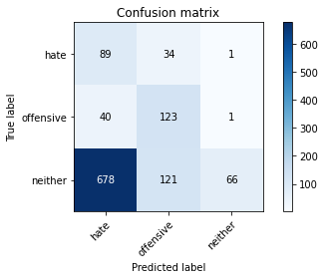

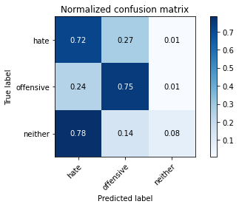

precision recall f1-score support

hate 0.11 0.72 0.19 124

offensive 0.44 0.75 0.56 164

neither 0.97 0.08 0.14 865

accuracy 0.24 1153

macro avg 0.51 0.51 0.30 1153

weighted avg 0.80 0.24 0.21 1153

average eval_loss: 1.0755781294970677, accuracy: 0.24111014744145706

training 2 epoch...

116.44964289665222 seconds used......

2 training finished! average train loss: 1.7420693426614715

total clf loss: 144.77861511707306 total adv loss: 73.94451719522476

evaluating...

Confusion matrix, without normalization

[[ 96 24 4]

[ 46 115 3]

[581 79 205]]

Normalized confusion matrix

[[0.77419355 0.19354839 0.03225806]

[0.2804878 0.70121951 0.01829268]

[0.6716763 0.09132948 0.23699422]]

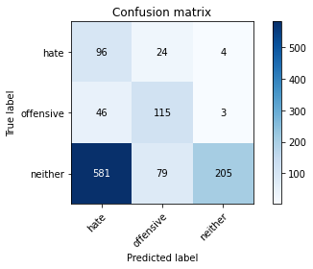

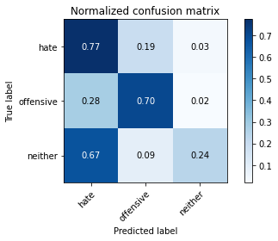

precision recall f1-score support

hate 0.13 0.77 0.23 124

offensive 0.53 0.70 0.60 164

neither 0.97 0.24 0.38 865

accuracy 0.36 1153

macro avg 0.54 0.57 0.40 1153

weighted avg 0.81 0.36 0.40 1153

average eval_loss: 0.9864162473843016, accuracy: 0.36079791847354725

training 3 epoch...

116.68787121772766 seconds used......

3 training finished! average train loss: 1.3570229361454647

total clf loss: 121.28312388062477 total adv loss: 53.34836445003748

evaluating...

Confusion matrix, without normalization

[[ 67 42 15]

[ 36 120 8]

[358 101 406]]

Normalized confusion matrix

[[0.54032258 0.33870968 0.12096774]

[0.2195122 0.73170732 0.04878049]

[0.41387283 0.11676301 0.46936416]]

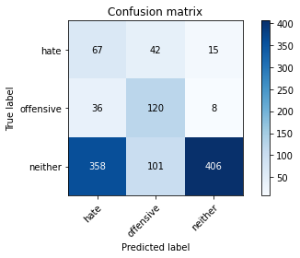

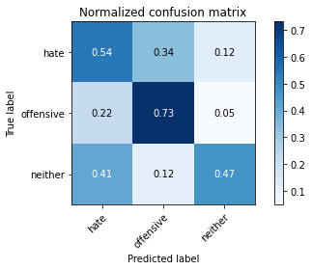

precision recall f1-score support

hate 0.15 0.54 0.23 124

offensive 0.46 0.73 0.56 164

neither 0.95 0.47 0.63 865

accuracy 0.51 1153

macro avg 0.52 0.58 0.47 1153

weighted avg 0.79 0.51 0.58 1153

average eval_loss: 0.9107342444617172, accuracy: 0.5143104943625325

training 4 epoch...

116.72202277183533 seconds used......

4 training finished! average train loss: 0.8893237186684495

total clf loss: 91.84045827388763 total adv loss: 28.782963229343295

evaluating...

Confusion matrix, without normalization

[[ 73 29 22]

[ 34 118 12]

[323 85 457]]

Normalized confusion matrix

[[0.58870968 0.23387097 0.17741935]

[0.20731707 0.7195122 0.07317073]

[0.3734104 0.0982659 0.5283237 ]]

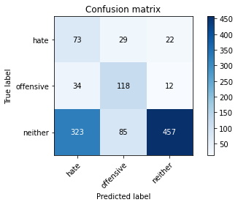

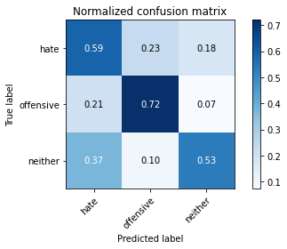

precision recall f1-score support

hate 0.17 0.59 0.26 124

offensive 0.51 0.72 0.60 164

neither 0.93 0.53 0.67 865

accuracy 0.56 1153

macro avg 0.54 0.61 0.51 1153

weighted avg 0.79 0.56 0.62 1153

average eval_loss: 1.0061858820504155, accuracy: 0.562012142237641

training 5 epoch...

116.72557950019836 seconds used......

5 training finished! average train loss: 0.5493426087888933

total clf loss: 65.11782494187355 total adv loss: 13.585866703884676

evaluating...

Confusion matrix, without normalization

[[ 70 20 34]

[ 37 99 28]

[288 51 526]]

Normalized confusion matrix

[[0.56451613 0.16129032 0.27419355]

[0.22560976 0.60365854 0.17073171]

[0.33294798 0.05895954 0.60809249]]

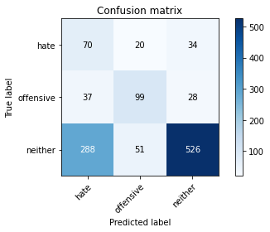

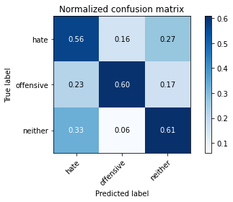

precision recall f1-score support

hate 0.18 0.56 0.27 124

offensive 0.58 0.60 0.59 164

neither 0.89 0.61 0.72 865

accuracy 0.60 1153

macro avg 0.55 0.59 0.53 1153

weighted avg 0.77 0.60 0.66 1153

average eval_loss: 1.0243001333598434, accuracy: 0.6027753686036427

training 6 epoch...

116.68165183067322 seconds used......

6 training finished! average train loss: 0.3813802767101498

total clf loss: 48.874518893659115 total adv loss: 7.598684073989716

evaluating...

Confusion matrix, without normalization

[[ 91 23 10]

[ 47 109 8]

[499 77 289]]

Normalized confusion matrix

[[0.73387097 0.18548387 0.08064516]

[0.28658537 0.66463415 0.04878049]

[0.57687861 0.08901734 0.33410405]]

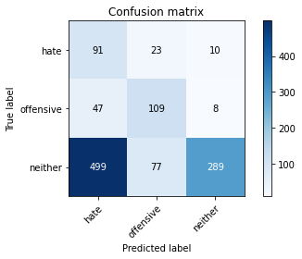

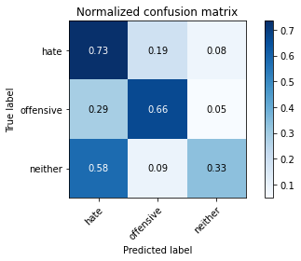

precision recall f1-score support

hate 0.14 0.73 0.24 124

offensive 0.52 0.66 0.58 164

neither 0.94 0.33 0.49 865

accuracy 0.42 1153

macro avg 0.54 0.58 0.44 1153

weighted avg 0.80 0.42 0.48 1153

average eval_loss: 1.6016392235098214, accuracy: 0.4241110147441457

training 7 epoch...

116.80289578437805 seconds used......

7 training finished! average train loss: 0.2690347590528074

total clf loss: 31.43357759900391 total adv loss: 6.882130949757993

evaluating...

Confusion matrix, without normalization

[[ 92 23 9]

[ 45 112 7]

[468 67 330]]

Normalized confusion matrix

[[0.74193548 0.18548387 0.07258065]

[0.27439024 0.68292683 0.04268293]

[0.54104046 0.07745665 0.38150289]]

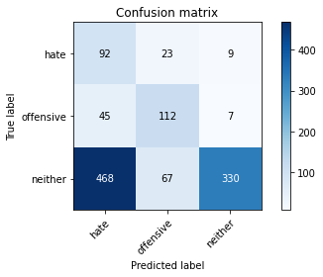

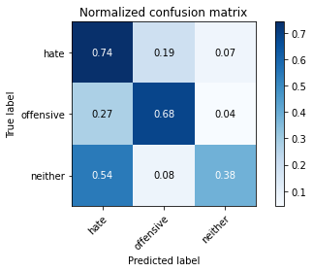

precision recall f1-score support

hate 0.15 0.74 0.25 124

offensive 0.55 0.68 0.61 164

neither 0.95 0.38 0.55 865

accuracy 0.46 1153

macro avg 0.55 0.60 0.47 1153

weighted avg 0.81 0.46 0.52 1153

average eval_loss: 1.8622998112234577, accuracy: 0.46313963573287076

training 8 epoch...

116.70906949043274 seconds used......

8 training finished! average train loss: 0.19444511622367872

total clf loss: 21.006591177545488 total adv loss: 5.830094206134163

evaluating...

Confusion matrix, without normalization

[[ 82 20 22]

[ 49 99 16]

[352 58 455]]

Normalized confusion matrix

[[0.66129032 0.16129032 0.17741935]

[0.29878049 0.60365854 0.09756098]

[0.40693642 0.06705202 0.52601156]]

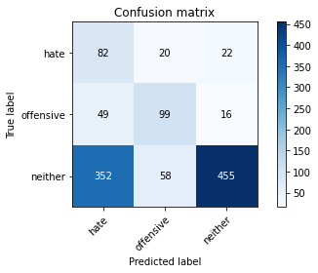

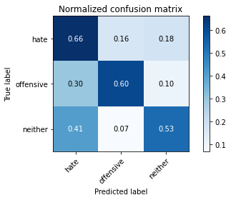

precision recall f1-score support

hate 0.17 0.66 0.27 124

offensive 0.56 0.60 0.58 164

neither 0.92 0.53 0.67 865

accuracy 0.55 1153

macro avg 0.55 0.60 0.51 1153

weighted avg 0.79 0.55 0.61 1153

average eval_loss: 1.649860860972569, accuracy: 0.5516045099739809

training 9 epoch...

116.63239884376526 seconds used......

9 training finished! average train loss: 0.16533080683023268

total clf loss: 15.963850405067205 total adv loss: 5.905862647603499

evaluating...

Confusion matrix, without normalization

[[ 95 19 10]

[ 49 102 13]

[493 72 300]]

Normalized confusion matrix

[[0.76612903 0.15322581 0.08064516]

[0.29878049 0.62195122 0.07926829]

[0.5699422 0.08323699 0.34682081]]

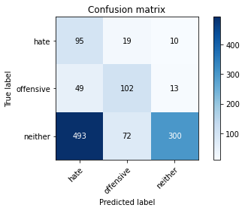

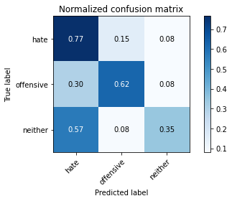

precision recall f1-score support

hate 0.15 0.77 0.25 124

offensive 0.53 0.62 0.57 164

neither 0.93 0.35 0.51 865

accuracy 0.43 1153

macro avg 0.54 0.58 0.44 1153

weighted avg 0.79 0.43 0.49 1153

average eval_loss: 2.442581125374498, accuracy: 0.43104943625325237

training 10 epoch...

116.58831095695496 seconds used......

10 training finished! average train loss: 0.09380569971316229

total clf loss: 10.643415926024318 total adv loss: 2.557970807514721

evaluating...

Confusion matrix, without normalization

[[ 85 24 15]

[ 44 108 12]

[463 52 350]]

Normalized confusion matrix

[[0.68548387 0.19354839 0.12096774]

[0.26829268 0.65853659 0.07317073]

[0.53526012 0.06011561 0.40462428]]

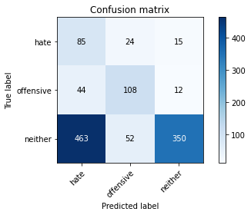

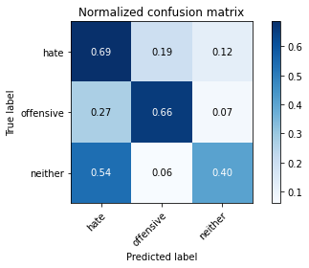

precision recall f1-score support

hate 0.14 0.69 0.24 124

offensive 0.59 0.66 0.62 164

neither 0.93 0.40 0.56 865

accuracy 0.47 1153

macro avg 0.55 0.58 0.47 1153

weighted avg 0.80 0.47 0.54 1153

average eval_loss: 2.4628062628466507, accuracy: 0.47094535993061576

5 run......

training 1 epoch...

116.56922316551208 seconds used......

1 training finished! average train loss: 2.070198403227897

total clf loss: 166.27531945705414 total adv loss: 90.75900667905807

evaluating...

Confusion matrix, without normalization

[[ 96 22 6]

[ 53 109 2]

[605 86 174]]

Normalized confusion matrix

[[0.77419355 0.17741935 0.0483871 ]

[0.32317073 0.66463415 0.01219512]

[0.69942197 0.09942197 0.20115607]]

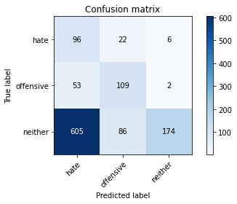

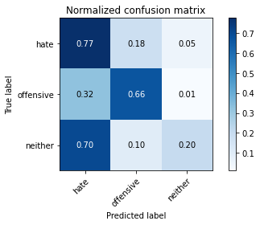

precision recall f1-score support

hate 0.13 0.77 0.22 124

offensive 0.50 0.66 0.57 164

neither 0.96 0.20 0.33 865

accuracy 0.33 1153

macro avg 0.53 0.55 0.37 1153

weighted avg 0.80 0.33 0.35 1153

average eval_loss: 0.9845462143421173, accuracy: 0.32870771899392887

training 2 epoch...

116.75098776817322 seconds used......

2 training finished! average train loss: 1.7449794837406702

total clf loss: 145.23343294858932 total adv loss: 73.96155999600887

evaluating...

Confusion matrix, without normalization

[[ 93 22 9]

[ 46 111 7]

[501 54 310]]

Normalized confusion matrix

[[0.75 0.17741935 0.07258065]

[0.2804878 0.67682927 0.04268293]

[0.57919075 0.06242775 0.3583815 ]]

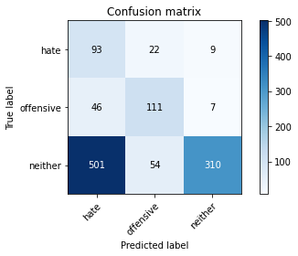

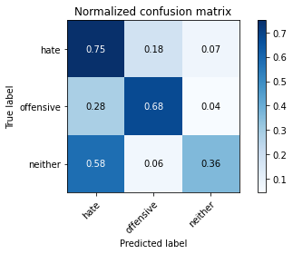

precision recall f1-score support

hate 0.15 0.75 0.24 124

offensive 0.59 0.68 0.63 164

neither 0.95 0.36 0.52 865

accuracy 0.45 1153

macro avg 0.56 0.60 0.47 1153

weighted avg 0.81 0.45 0.51 1153

average eval_loss: 0.9146320799301411, accuracy: 0.4457935819601041

training 3 epoch...

116.77046370506287 seconds used......

3 training finished! average train loss: 1.425626777112484

total clf loss: 124.74390512704849 total adv loss: 57.380696050822735

evaluating...

Confusion matrix, without normalization

[[ 86 19 19]

[ 45 103 16]

[392 47 426]]

Normalized confusion matrix

[[0.69354839 0.15322581 0.15322581]

[0.27439024 0.62804878 0.09756098]

[0.45317919 0.05433526 0.49248555]]

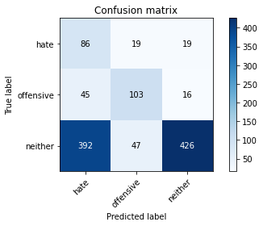

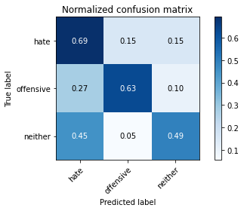

precision recall f1-score support

hate 0.16 0.69 0.27 124

offensive 0.61 0.63 0.62 164

neither 0.92 0.49 0.64 865

accuracy 0.53 1153

macro avg 0.57 0.60 0.51 1153

weighted avg 0.80 0.53 0.60 1153

average eval_loss: 0.8892823293291289, accuracy: 0.5333911535125759

training 4 epoch...

116.94642925262451 seconds used......

4 training finished! average train loss: 0.9553199539936724

total clf loss: 94.5761316716671 total adv loss: 32.958810115233064

evaluating...

Confusion matrix, without normalization

[[ 84 23 17]

[ 40 110 14]

[339 80 446]]

Normalized confusion matrix

[[0.67741935 0.18548387 0.13709677]

[0.24390244 0.67073171 0.08536585]

[0.39190751 0.09248555 0.51560694]]

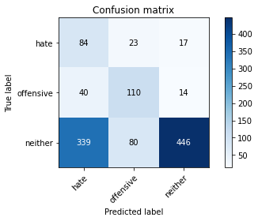

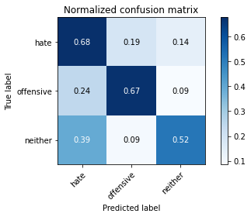

precision recall f1-score support

hate 0.18 0.68 0.29 124

offensive 0.52 0.67 0.58 164

neither 0.94 0.52 0.66 865

accuracy 0.56 1153

macro avg 0.54 0.62 0.51 1153

weighted avg 0.79 0.56 0.61 1153

average eval_loss: 0.9500171871020876, accuracy: 0.5550737207285342

training 5 epoch...

116.68050718307495 seconds used......

5 training finished! average train loss: 0.582146014397343

total clf loss: 66.94996225833893 total adv loss: 15.425283971242607

evaluating...

Confusion matrix, without normalization

[[ 77 39 8]

[ 30 124 10]

[391 96 378]]

Normalized confusion matrix

[[0.62096774 0.31451613 0.06451613]

[0.18292683 0.75609756 0.06097561]

[0.45202312 0.11098266 0.43699422]]

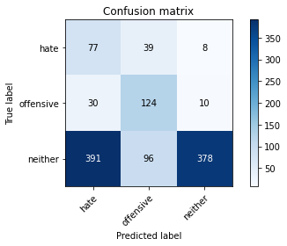

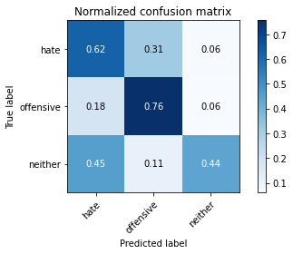

precision recall f1-score support

hate 0.15 0.62 0.25 124

offensive 0.48 0.76 0.59 164

neither 0.95 0.44 0.60 865

accuracy 0.50 1153

macro avg 0.53 0.60 0.48 1153

weighted avg 0.80 0.50 0.56 1153

average eval_loss: 1.337066806595901, accuracy: 0.5021682567215958

training 6 epoch...

116.74249505996704 seconds used......

6 training finished! average train loss: 0.3524452833724873

total clf loss: 44.92617017775774 total adv loss: 7.1423186342581175

evaluating...

Confusion matrix, without normalization

[[ 88 24 12]

[ 42 110 12]

[435 63 367]]

Normalized confusion matrix

[[0.70967742 0.19354839 0.09677419]

[0.25609756 0.67073171 0.07317073]

[0.50289017 0.07283237 0.42427746]]

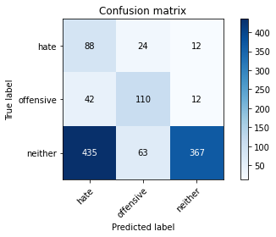

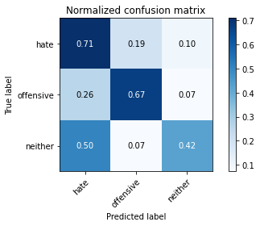

precision recall f1-score support

hate 0.16 0.71 0.26 124

offensive 0.56 0.67 0.61 164

neither 0.94 0.42 0.58 865

accuracy 0.49 1153

macro avg 0.55 0.60 0.48 1153

weighted avg 0.80 0.49 0.55 1153

average eval_loss: 1.5258010235326043, accuracy: 0.4900260190806591

training 7 epoch...

116.7760238647461 seconds used......

7 training finished! average train loss: 0.26348783055852565

total clf loss: 31.292373307049274 total adv loss: 6.486791063056444

evaluating...

Confusion matrix, without normalization

[[ 78 25 21]

[ 34 114 16]

[314 68 483]]

Normalized confusion matrix

[[0.62903226 0.2016129 0.16935484]

[0.20731707 0.69512195 0.09756098]

[0.36300578 0.07861272 0.5583815 ]]

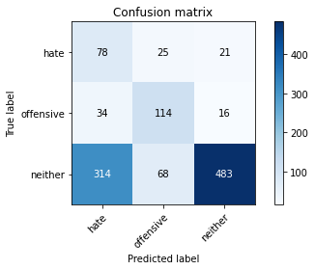

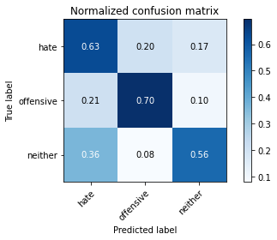

precision recall f1-score support

hate 0.18 0.63 0.28 124

offensive 0.55 0.70 0.61 164

neither 0.93 0.56 0.70 865

accuracy 0.59 1153

macro avg 0.55 0.63 0.53 1153

weighted avg 0.79 0.59 0.64 1153

average eval_loss: 1.448786440594443, accuracy: 0.585429314830876

training 8 epoch...

116.77010440826416 seconds used......

8 training finished! average train loss: 0.2332357045130006

total clf loss: 25.023056028410792 total adv loss: 7.080271198850824

evaluating...

Confusion matrix, without normalization

[[ 85 23 16]

[ 44 106 14]

[416 62 387]]

Normalized confusion matrix

[[0.68548387 0.18548387 0.12903226]

[0.26829268 0.64634146 0.08536585]

[0.48092486 0.0716763 0.44739884]]

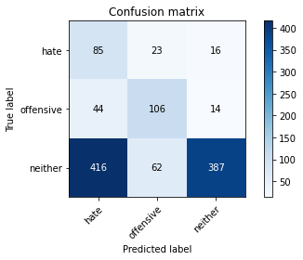

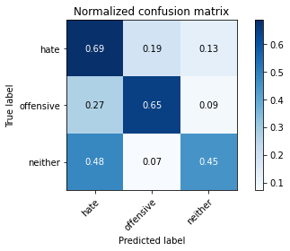

precision recall f1-score support

hate 0.16 0.69 0.25 124

offensive 0.55 0.65 0.60 164

neither 0.93 0.45 0.60 865

accuracy 0.50 1153

macro avg 0.55 0.59 0.49 1153

weighted avg 0.79 0.50 0.57 1153

average eval_loss: 1.819789195882863, accuracy: 0.5013009540329575

training 9 epoch...

116.64023089408875 seconds used......

9 training finished! average train loss: 0.15858222531443017

total clf loss: 16.479966703336686 total adv loss: 5.0809234950866085

evaluating...

Confusion matrix, without normalization

[[ 97 16 11]

[ 43 101 20]

[456 47 362]]

Normalized confusion matrix

[[0.78225806 0.12903226 0.08870968]

[0.26219512 0.61585366 0.12195122]

[0.52716763 0.05433526 0.41849711]]

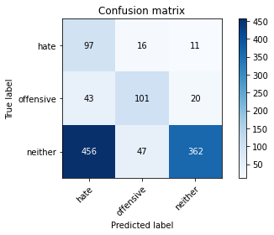

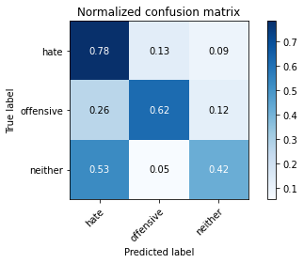

precision recall f1-score support

hate 0.16 0.78 0.27 124

offensive 0.62 0.62 0.62 164

neither 0.92 0.42 0.58 865

accuracy 0.49 1153

macro avg 0.57 0.61 0.49 1153

weighted avg 0.80 0.49 0.55 1153

average eval_loss: 2.2831272328722068, accuracy: 0.4856895056374675

training 10 epoch...

116.55100226402283 seconds used......

10 training finished! average train loss: 0.10664049906301357

total clf loss: 11.105309453094378 total adv loss: 3.405147170901728

evaluating...

Confusion matrix, without normalization

[[ 98 11 15]

[ 41 108 15]

[469 54 342]]

Normalized confusion matrix

[[0.79032258 0.08870968 0.12096774]

[0.25 0.65853659 0.09146341]

[0.54219653 0.06242775 0.39537572]]

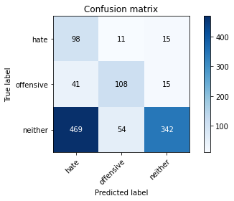

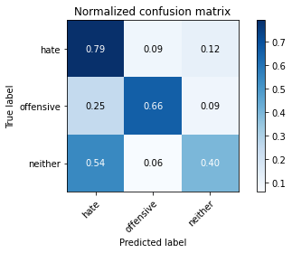

precision recall f1-score support

hate 0.16 0.79 0.27 124

offensive 0.62 0.66 0.64 164

neither 0.92 0.40 0.55 865

accuracy 0.48 1153

macro avg 0.57 0.61 0.49 1153

weighted avg 0.80 0.48 0.53 1153

average eval_loss: 2.383784592151642, accuracy: 0.47528187337380745